Genevieve B. Hammer, PT, DPT, OCS
Physical Therapist, Board Certified Orthopedic Clinical Specialist
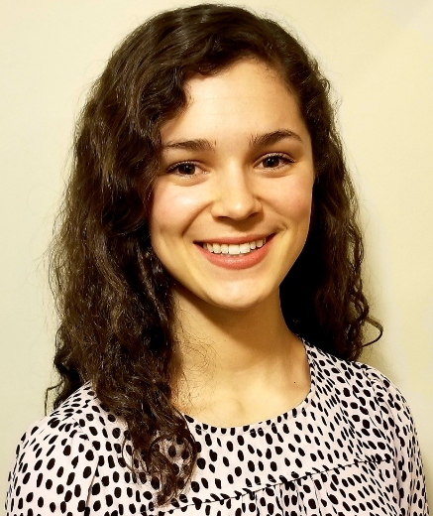
Genevieve received her Doctor of Physical Therapy (DPT) degree from the MGH Institute of Health Professions. She enjoys treating patients with all orthopedic injuries, vestibular dysfunction, and gait training for amputees. She has completed advanced training in spinal manipulation as well as joint mobilization. Genevieve enjoys teaching as a lab instructor in the DPT program at Franklin Pierce University. She is also a clinical instructor for DPT students. Outside of the clinic, Genevieve enjoys hiking, cycling, swimming, and weight lifting.
Education | Doctor of Physical Therapy, MGH Institute of Health Professions  Bachelor of Science in Kinesiology, University of Maryland College Park
Specialties | Board Certified Orthopedic Clinical Specialist (OCS)  Manual Therapy, including Spinal Manipulation and Joint Mobilizations  Spine  Sports Medicine  Dry Needling  Vestibular Rehabilitation  Amputee Gait Training

